Appendix A. Rubrics for Assessing Media Report Fidelity

This document presents the rubrics used by coders to assess the fidelity of media reports on behavioral science research, displayed as a questionnaire on Qualtrics.
Note: Text enclosed in square brackets [like this] represents explanatory information.

0. Basic Information
- Please enter information for the following fields:
0(a). Research paper title ________; URL ________
0(b). Media article title ________; URL ________; word count ________
0(c). Number of research paper(s) in the media article.
Sometimes a media article reports the findings from one particular research paper, whereas other times it shares a clearly formed opinion by citing multiple research papers. Please select below the number of research paper(s) mentioned in this media article.
[Dropdown Menu]
[Qualtrics survey logic: The Qualtrics-enabled rubrics will only continue if coders select a number less or equal to 3 for Q0(c). Otherwise, the program will terminate automatically.]

- Research Paper Composition
1(a). Please select the number of distinct studies presented in the research paper [Dropdown Menu]
Distinct studies: A study can take on different forms, including (but not limited to) a Lab Study, a Field Study, or a Simulation. A study is considered distinct as long as it has its own naming. For example, Study 1a and Study 1b are considered as two distinct studies.
Different research papers can have different naming systems. The list below is just a few examples:
Naming System | Number of Distinct Studies
Lab Study, Field Study | 2
Study 1, Study 2, Study 3 | 3
Experiment 1, Experiment 2, Experiment 3 | 3
Experiment 1a, Experiment 1b, Field Study | 3
Study 1A, Study 1B, Study 1C, Study 2 | 4
Lab Study 1, Lab Study 2, Field Study, Simulation | 4

1(b). Labeling of Studies in the Research Paper.
You indicated the research paper covers [Piped Texts from Q1(a)] distinct studies. Please enter the actual labeling of distinct studies in the research paper in order.
E.g., Study 1a/2a/2b/2c input "Study 1a/2a/2b/2c" respectively; Lab Study 1 input "Lab Study 1"; Experiment 1 input "Experiment 1" or "Exp. 1"; Field Study 2 input "Field Study 2", etc.
[Space for coders to list study labels]

1(c). Media Mentions of the Studies in the Research Paper
Which of the distinct studies in the research paper is mentioned by the media article, if any?
If you choose "The media article refers to the research paper as a whole," there is NO need to select individual studies.
If the research paper only has ONE distinct study, please choose "the media article refers to the research paper a whole."
[Checkbox: Study Labels]

- Research Methodology
Research methods used in the research paper (please code each study)
[The exhibit below is an illustration of what coders see on Qualtrics.]
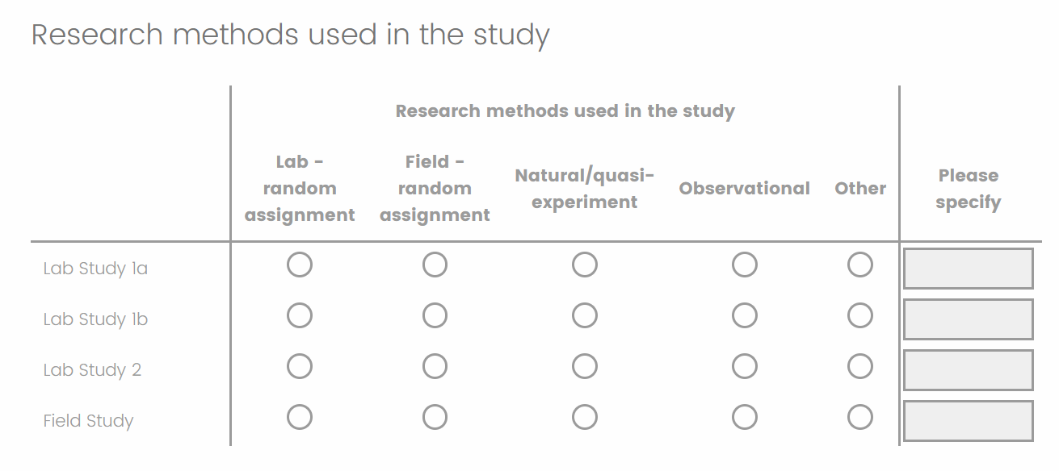

- Relation Between Variables
The coding should focus on the highest level of relation established in the research paper. For example, if a research paper reports seven distinct studies – one established causal evidence and six correlational, a coder should code the research paper as claiming causal evidence.
How does the media article describe the relation between independent (treatment) and dependent (outcome) variables examined in the research paper? (Please code the research paper as a whole – only ONE choice is needed)
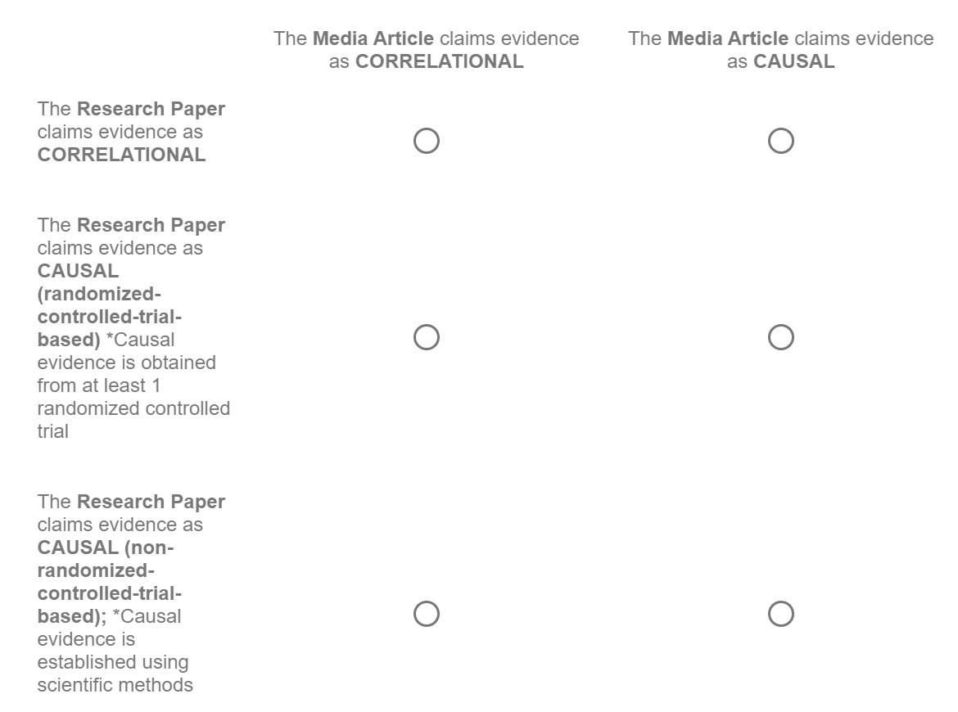
- Number of Broad Domain(s) Described in the Research Paper
Definition of Broad Domain
The domain for which the research question is formulated
Instructions on the Choice

Choose the second option (multiple broad domains) when: a research paper applies a general principle (e.g., the use of reminders) to investigate how it can be implemented in both financial domain (bill payment) and health domain (medical appointment).

Choose the third option (domain-free) when: all studies were tested in abstract theory settings, devoid of domains. Typical examples include psychometrics and theory-testing.

Choose the fourth option (other, please specify) when: no other options apply. Coders should explain why the answer is ambiguous.

Note. If a research paper contains 6 domain-free studies and 1 study in a particular domain, the coder should choose "in a single broad domain". Answers should be given based on the highest level. For the purposes of this question, domain-specific is of a higher level than domain-free.

The research questions examined by the research paper are:
- In a single broad domain (e.g., health, finance)

- In multiple broad domains (e.g., health and finance)

- Tested in an abstract theory setting, devoid of domains (e.g., psychometrics). Select this option only when all studies are domain-free.

- Other, please specify [Textbox]

- Broad and Specific Domains
In the last question, you indicated the number of broad domain(s) covered by a research paper, please now specify what these broad domain(s) are. In addition, please also specify what within these broad domain(s) the research paper examines. The same information is collected for a media article as well (if applicable).
When specifying domains, we focus on the domain(s) of behavioral change. That is, where is the behavioral change happening?
For example:
Research Topics | Broad Domain | Specific Domain
Decision to get Covid vaccine | Health | Vaccine
Choice of retirement plans | Savings | Retirement plan
Willingness to use a self-driving car | Technology | Self-driving car
Increase the use of public transportation | Environment | Public transportation usage

5(a). The research paper examines the broad domain(s) of ____
5(b). The media article reports the broad domain(s) of ____
5(c). The research paper examines the specific domain(s) of (if applicable) ______.

[Qualtrics survey logic: Question 5(d-1) will only be displayed if the first, second, or fourth option is selected for Question 4.]
5(d-1). Does the media article discuss findings at the same specific domain(s) as the research paper?
- Yes, the media article discusses at the same specific domain(s) as the research paper.

- No, the media article discusses different broad domain(s), and thus different specific domain(s), than the research paper (e.g., research paper: vaccine media article: retirement plan).
List the specific domain(s) described in the media article: ________

- No, the media article discusses same broad domain(s) but different specific domain(s) than the research paper (e.g., research paper: vaccine media article: weight loss, both under the broad domain Health).
List the specific domain(s) described in the media article: _________

- No, the media article discusses domain(s) that are broader than those covered in the research paper (e.g., research paper: vaccine media article: talk about health in general)

[Qualtrics survey logic: Question 5(d-2) will only be displayed if the third option is selected for Question 4.]

5(d-2). In Q3, you indicated that the research paper tests all studies in abstract theory settings (i.e., domain-free). Has the specific domain discussed in the media article been tested in (one of the studies of) the research paper?
- Yes

- No
Explanatory Notes: For broad domains, coders labeled the domains of application described in the research articles and media reports, respectively. In our analysis, we evaluated whether each pair of labels matched. An exception was made when the broad domains listed for the media report were a subset of those for the research article, which was still considered “matched”. For specific domains, coders directly indicated whether the domains matched. If unfaithful generalizations were selected, coders were prompted to label the specific domains.

- Presentation of the Dependent/Outcome Variable(s) along the Attitude-Intention-Behavior Hierarchy

- Attitude/belief: Evaluation or liking, verbal support (supporting a policy; giving a Facebook like to charitable cause while the goal is to raise funds).

- Intention: Likelihood to do something (what people say they will do).

- Behavior: What people actually do (e.g., donating money). Behavior means action; it means what a person does to make something happen, to make something change, or to keep things the same.
Responses below should NOT be considered a behavior:
- Selecting an answer on a Likert scale is NOT a behavioral response despite the action of selecting something. It’s either attitude/belief for intention depending on the question.
- Indicating a behavior in a hypothetical scenario is NOT a behavioral response. For example, imagine you are in situation X, would you do A or B? This is NOT a behavior.
If a media article focuses on a subset of studies in the research paper, please specify with labeling.

Example 1:
 | Reported in Research Paper | Claimed by Media Article
Attitude/Belief | Study 1, Study 3
Intention | Study 2, Study 3
Behavior |  | Whole
In this example, while the highest level of outcome variable in the research paper is Intention (Study 2, Study 3), the media article claims it to be Behavior. This discrepancy indicates a mismatch.

Example 2:
 | Reported in Research Paper | Claimed by Media Article
Attitude/Belief | Study 1
Intention | Study 2, Study 3
Behavior | Study 3 | Whole
In this example, the highest level of outcome variable in the research paper is Behavior (Study 3), and the media article claims it to be Behavior. This indicates a match.

Example 3:
 | Reported in Research Paper | Claimed by Media Article
Attitude/Belief | Study 1
Intention | Study 2, Study 3
Behavior | Study 3 | Study 2

In this example, the media article focuses only on Study 2, and claims the outcome variable to be Behavior. This results in a mismatch because the outcome variable in Study 2 is Intention in the research paper, despite that the highest level of outcome variable is Behavior (Study 3). When a media report focuses on a particular study in the research paper, we look at the reporting of that specific study.
Discrepancies in the levels along the attitude-intention-behavior hierarchy are considered a mistake.
Previously you reported that the research paper has [Piped Texts from Q1(b)]. Please indicate what type of outcome variables each distinct study represents along the attitude-intention-behavior-hierarchy.
For the research paper, please use the actual labeling of distinct studies you input at the beginning of this survey.
You also indicated that the media article reported [Piped Texts from Q1(c)].
For the media article, if it refers to the research paper as a whole, please enter ‘Whole.” We focus on the highest level of outcome variables along the hierarchy. For example, if a media article claims variables to be both Intention and Behavior, the level claimed by this media article should be noted as Behavior.
 | Reported in Research Paper | Claimed by Media Article
Attitude/Belief
Intention
Behavior

- Details on the Participants
7(a). Are the attributes listed below mentioned in the research paper and/or the media article? (Select all that apply)
If an attribute is mentioned by the research paper but not the media article at all, please only select “Research paper” for the attribute.

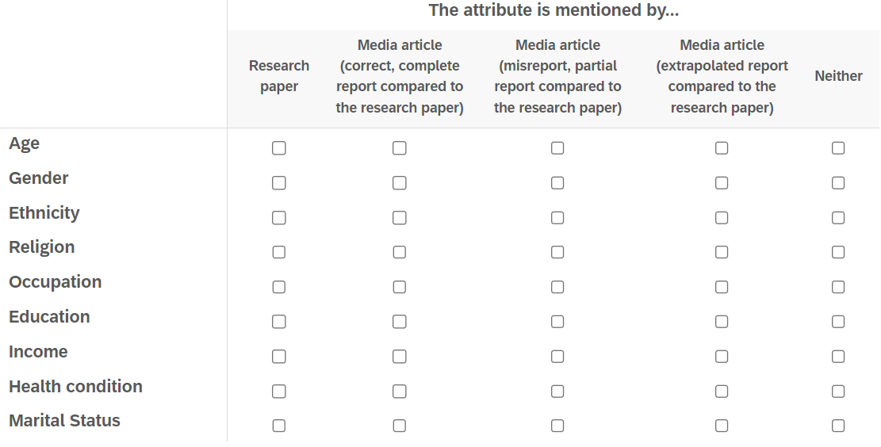

7(b). Apart from the attributes listed above, if there are any other demographic attributes mentioned in the research paper AND/OR media article, please specify.
[Space for coders to enter other demographic attributions, if any]
7(c). Are the attributes you previously input mentioned in the research paper and/or the media article? (Select all that apply)
If the attribute you input is mentioned by the research paper but not the media article at all, please only select “Research paper” for that attribute.
If the attribute you input is mentioned by only the media article, please only select “Media article (and only by the media article)” for that attribute.
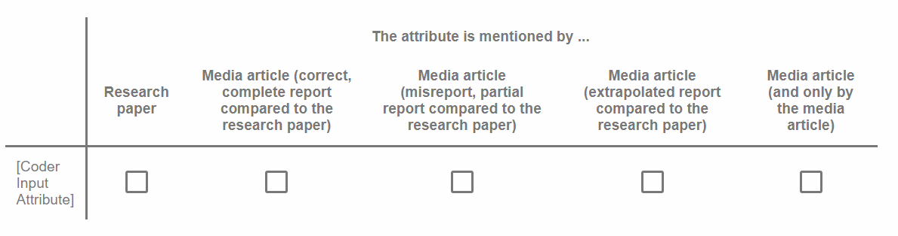
- Details on Context
Contexts play an important role in the efficacy of interventions. Here, we identify 5 contextual dimensions: 1) timing, 2) physical environment, 3) interface, 4) social & cultural environment, and 5) choice architecture.
- Timing refers to the right moment as opposed to a specific point in the timeline (e.g., the experiment is conducted at 4pm in the afternoon). Of course, if the observed effect differs by time of the day such as morning vs. evening, we will consider that as timing too.
Examples of timing: a fresh start, pandemic, special occasions
- Physical environment refers to characteristics of the physical environment where experimentation takes place.
Examples of physical environment: quiet vs. noisy room, high vs. low temperature
- Nature of Interface refers to the format in which experimentation takes place.
Examples of interface: oral, written, digital (e.g., MTurk, online panel), face-to-face, AI
- Social, cultural environment refers to influences from the ‘people’ side
Examples of social & cultural environment: the presence of immediate relatives, different countries
- Choice architecture refers to the ways in which choices are presented to people
Examples of choice architecture: the size of choice set (out of how many alternatives people choose from). One cannot claim that just because tea is preferred over coffee (a choice between tea and coffee), it will be the preferred drink over all other beverages such as water and milk (e.g., a choice among tea, coffee, water, milk).
Example: The table below illustrates how a research paper and its media article report contextual details. While media articles can cover all dimensions described in a research paper, they may or may not report these details completely and/or faithfully.

Contextual Dimension | Research Paper | Media Article | Media Article Compared to the Research Paper
Timing | During work hours | Outside of work hours | Misreport, partial report
Physical Environment | Office cafeteria | Home kitchen | Misreport, partial report
Nature of Interface | In person | In person | Correct, complete report
Social & Cultural Environment | Global North | Everywhere in the world | Extrapolated report
Choice Architecture | Food arranged horizontally on a flat buffet table | Food arranged vertically in a fridge or pantry | Misreport, partial report

Given the example, the correct answers are as follows:
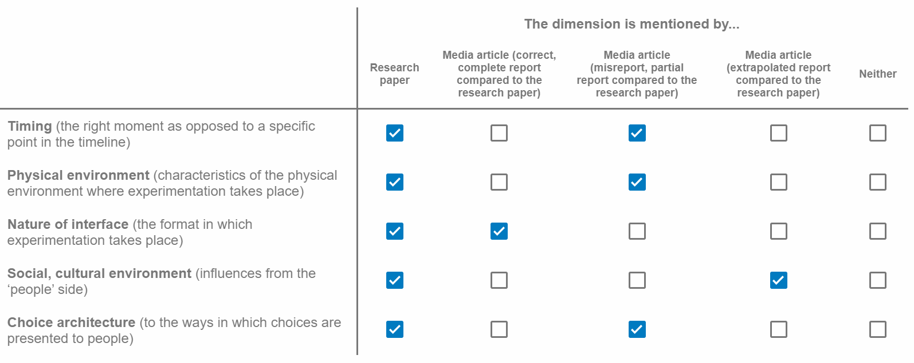

8(a). Are the dimensions of contexts listed below mentioned in the research paper and/or the media article? (Select all that apply)
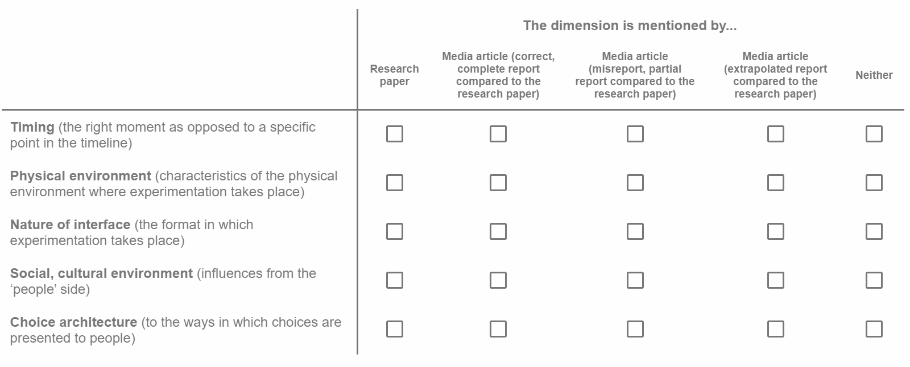
Any additional thoughts you would like to add? This can include things such as the debates you had with yourself when trying to categorize media reporting. [Textbox]
8(b). Apart from the dimensions listed earlier (timing, physical environment, interface, social & cultural environment, and choice architecture). If there are any other contextual dimensions being mentioned in the research paper AND/OR media article, please specify.
[Space for coders to enter other contextual dimensions, if any]

8(c). Are the contextual dimensions you previously input mentioned in the research paper and/or the media article? (Select all that apply)
If the contextual dimension you input is mentioned by the research paper but not the media article at all, please only select “Research paper” for that contextual dimension.
If the contextual dimension you input is mentioned by only the media article, please only select “Media article (and only by the media article)” for that contextual dimension.

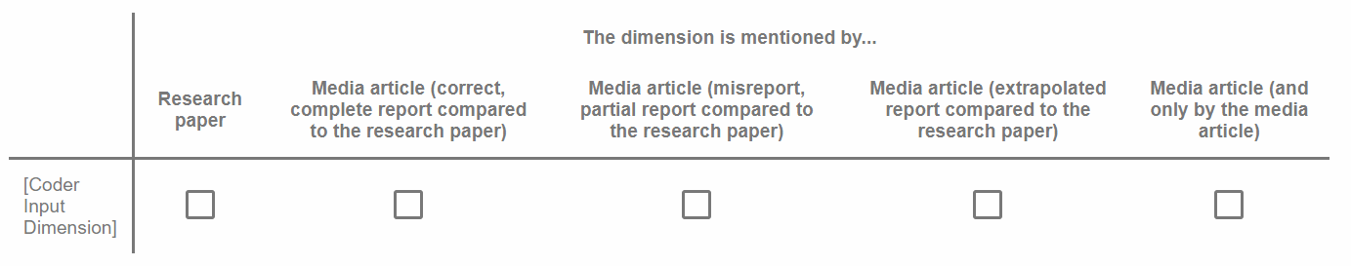
- The Use of Hypothetical Scenarios
9(a). Considering the research paper, was the conclusion drawn solely based on the use of hypothetical scenarios as methodology?
Hypothetical scenarios:
- Participants imagine themselves being different people with particular attributes (e.g., small business owner).

- Participants imagine themselves in a hypothetical scenario (e.g., open a bank account).

- Yes. Conclusion was drawn solely based on the use of hypothetical scenarios as methodology.

- No. Conclusion was backed up by at least one distinct study in which the participants experienced a real situation.
[Qualtrics survey logic: Question 9b will only be displayed if coders select “Yes” for Question 9(a).]

9(b). Did the media article mention that the conclusion was drawn solely based on the use of hypothetical scenarios as methodology?
- Yes

- No

- Limitations
Limitations refer to the research/methodology limitations or the extent to which findings are useful or not.
If limitations are mentioned by the research paper but not the media article at all, please only select “Research paper” for limitations.

Limitations are mentioned by (select all that apply):
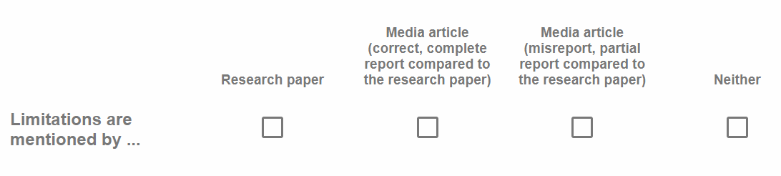

- Accuracy in Reporting Variables
Faithfully representing a variable means that the variable is presented as originally reported in the research paper. Coders just need to ask a simple question: Is the variable presented in the media article the same as the original one in the research? It is a Yes/No question with no shades of gray.
Below are examples of NOT faithfully representing a variable:
- Study on the effects of music (treatment variable) on memory in which memory was assessed using word recall (outcome variable). This was described by the media as finding an effect of music on vocabulary.

- Study that showed an effect of a treatment (treatment variable) on cognitive skills assessment (outcome variables), but the media reported on assessing IQ. (IQ ≠ cognitive skills)
Scope of this question: We only focus on a media report’s accuracy in reporting the treatment and outcome variables when describing research methodologies or findings, with no consideration of how these variables are later represented when discussing research implications. If a media writer faithfully reports treatment and/or outcome variables in describing a research finding but subsequently makes extrapolations in other parts of the article, the media article is still considered having faithfully reported the variables.
Explanations for the options below:
- The media article did not faithfully represent the X variable(s). This option covers different degrees of misrepresentation, from not at all faithful representation to partial faithful representation.

- All the X variables reported in the media article was/were faithfully represented in this option, we realize that sometimes a media article covers only a subset of an original research paper, and thus omits some variables given its coverage focus. We want to acknowledge this by focusing on all the variables reported in the media article (as opposed to those described in the research paper).

11(a). Did the media article faithfully represent the treatment/independent variable(s) in reporting the research findings?
- The media article did not faithfully represent the treatment/independent variable(s) in the research paper (from no faithful representation to partial faithful representation).

- All the treatment/independent variables reported in the media article was/were faithfully represented.
11(b). Did the media article faithfully represent the outcome/dependent variable(s) in reporting the research findings?
- The media article did not faithfully represent the outcome/dependent variable(s) in the research paper (from no faithful representation to partial faithful representation).

- All the outcome/dependent variables reported in the media article was/were faithfully represented.

- Presentation of Personal Opinions
How did the writer(s) of the media article present opinions? (Select all that apply)
We consider two types of opinions and made clear references below: 1) opinion of the writer(s) of the media article; 2) opinions of the author(s) of the research paper, such as those presented in the General Discussion and Future Directions.
- The writer(s) of the media article offered their own opinions and labeled as such.

- The writer(s) of the media article offered their own opinions without acknowledging so.

- The writer(s) of the media article presented opinions discussed by the author(s) of the research paper as scientific facts. This includes (but is not limited to) presenting opinions from the General Discussion and Future Directions as scientific facts.

- The writer(s) of the media article mixed their own opinions and those of the author(s) of the research paper.

- The Use of Research Findings in the Media Article

Example: A common example would be a media article claiming treatment variables as solutions to summative endpoint outcomes – an outcome that is caused by a combination of factors.
E.g., weight loss outcome is a summative endpoint outcome that is determined by diet, exercise, lifestyle, and other factors. Suppose the studied behavior (Y-variable) is food choice at a single decision point (choice of fruit bowl over chocolate as a snack), and a manipulation (X-variable) is believed to influence the studied behavior. If the media article frames the manipulation as a way to help people lose weight while the research paper has only measured food choice at a single decision point, we say that there is an over-generalization from behavior to a summative endpoint outcome. Another example: studied behavior = signing up for a class, summative endpoint outcome = upward mobility
Please draw a distinction between a media article’s framing and intervention around an important summative endpoint outcome and claiming that an intervention can result in the summative endpoint outcome.
What is the relationship between the key point(s)/recommendation(s)/takeaway(s) in the media article relative to the evidence in the research paper?
- The media article’s recommendations are directly backed up by the evidence in the research paper.

- The media article extrapolates from the results of the research paper and offers recommendations that are implied but not tested in the research paper.

- Headline
14(a). Is the headline of the media article generic (i.e., not related to the content f the media article)?
Headlines like “Rotman Overview,” “Weekly Briefing,” “Trends in Behavioral Science 2021” are generic.
- Yes

- No
[The initial plan was for the survey logic to display Question 14(b) if coders select “No” for Question 14(a) and terminate the survey otherwise. However, the logic was
mistakenly programmed to do the reverse – i.e., it terminated when coders selected “No” for Question 14(a). Consequently, insufficient data was collected to proceed with further analysis of media report headlines.]

14(b). How does the headline of the media article reflect the research papers? (Select all that apply)
This question asks if the potential problems identified in the previous questions regarding media article reporting are also reflected in the headline of the media article.
- The headline is mismatched on some, or all, of the outcome variable(s). If they are not the same IV, it is a mismatch.

- The headline suggests a cause-and-effect relationship between treatment and outcome variables while the research paper has only correlational evidence. For example, drinking coffee might lower health risks.

- The headline claims a cause-and-effect relationship between treatment and outcome variables while the research paper has only correlational evidence. For example, drinking coffee lowers health risks.
- The headline suggests a within-domain generalization from one specific domain to another specific domain, despite being under the same broad domain (e.g., from vaccine to weight loss, despite both failing under health).

- The headline suggests a cross-domain generalization from one broad domain to another broad domain (e.g., from health to saving).

- The headline extrapolates beyond the evidence in the research paper

- The media article has a headline that correctly reflects the research paper.

A list of causative verbs and/or words that indicate causality:
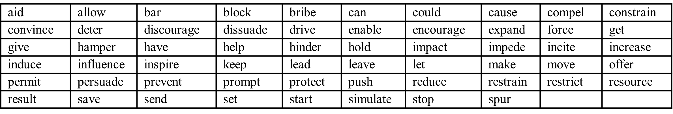
A list of headline examples suggesting causality:

- How think about “future you” can build a happier life

- Using smartphone could help improve memory skills

- Sharing memories with toddlers helps their well-being into adulthood

- Higher voice pitch lets female faces appear younger

- Why heat makes us sleepy

- Wearable activity trackers encourage us to walk up to 40 minutes more each day

- How breastfeeding offers immune benefits

- Mindfulness mediation reduces pain by separating it from the self

- Making sure workers have a “good” day gives companies a competitive advantage

- Long term high-fat diet expands waistline and shrinks brain

Appendix B. Journal, Research Article, and Media Report Selection

Journal Selection
We focused on the years 2017 to 2021, encompassing the pre-, mid-, and post-pandemic periods. The criteria for selecting journals were informed by a recent survey conducted among 177 behavioral science practitioners from a wide range of practice areas (Yu & Feng, 2024). This survey suggested that the three top journals that practitioners draw from are Behavioural Public Policy (BPP), Behavioral Science & Policy Association (BSPA), and Nature Human Behaviour (NHB). Furthermore, we wanted a journal for which media reports were available. We used Altmetric.com, a data science company that tracks online mentions of research, to evaluate the identification and accessibility of media reports citing research articles published in BPP, BSPA, and NHB. Altmetric.com was not integrated into BSPA at the time of our journal selection in August 2022, leading to its exclusion. Additionally, BPP was also removed due to insufficient data points on Altmetric.com regarding media coverage. Consequently, NHB became the final journal of choice.
Research Article and Media Report Selection
When selecting research articles, our focus was solely on publications reporting empirical studies. Across different types of NHB publications, we included those categorized as Article (N = 322), Letter (N = 148; available till 2019), and Registered Report (N =10), totaling 480 research articles.
Given NHB’s broad coverage of research topics, we reached out to behavioral science practitioners in our network to identify articles potentially relevant for practice based on journal titles. We sorted 480 journal article titles randomly into 12 groups of 40 items each. Two practitioners evaluated each group (24 in total), and only titles deemed potentially relevant by both were included in the final pool of research articles. This criterion led to the inclusion of 136 research articles.
We categorized the 136 practice-relevant NHB research articles into three tiers based on media engagement: low, medium, and high. The number of news stories on Altmetric.com served as a proxy for this classification. From each of these three media engagement categories, we randomly selected four candidates, resulting in the final selection of 12 research articles.
For media reports, all those corresponding to the selected 12 NHB research articles tracked on Altmetric.com were considered valid candidates. Exceptions included reports that: 1) were not written in English, 2) covered more than three research articles, as such extensive coverage may lack sufficient depth on individual studies, or 3) had nonfunctioning links or links leading to reports differing from what the headlines suggested.
Coder Selection
We chose coders who were social science Ph.D. students in at least their 2nd year at the University of Toronto with a fundamental understanding of various types of variables, including independent and dependent variables, as well as contextual factors and participant characteristics. Additionally, we specifically sought coders with a good grasp of different research methodologies, such as RCTs and observational studies. At the time of coding, all but one coder had already passed their Comprehensive Exams.
Coding Management
We began the coding process with four coders, divided into two pairs. Each pair was assigned six of the 12 NHB research articles. They were asked to read and code the NHB articles according to the rubrics. Coders were also responsible for coding all accessible, non-repetitive media reports corresponding to the assigned NHB articles, as tracked on Altmetric.com. Since coders accessed Altmetric.com independently, the actual number of media reports coded could differ between coders in each pair, depending on the information available to them. We had no control over these discrepancies.
As previously mentioned, we initiated the coding process with four coders. However, one coder had to withdraw early due to extenuating circumstances and the intensive time commitment required for the coding task. Consequently, a fifth coder was brought in as a replacement. To maintain consistency throughout the process, the fifth started the entire coding task anew, rather than continuing from where the withdrawn coder left off. The withdrawn coder’s coding was hence excluded from all subsequent analyses. The final four coders completed their assigned tasks. The coding period spanned from mid-February 2023 to mid-August 2023.
The four coders coded 263 media reports altogether. Of these, 68 received complete, independent coding from two coders. For the remaining 195 reports, 167 were attempted by only one coder, 19 were started by two coders but completed by only one because the other indicated that the media report covered more than three research articles, and nine were excluded during screening because both coders indicated media coverage spanning more than three research articles. We included only the 68 media reports with two sets of complete coding because they enabled us to assess inter-coder reliability. These reports corresponded to 11 of the 12 chosen research articles, resulting in our final analysis comprising 11 research articles and their 68 corresponding media reports (Appendix C).

Appendix C. Research Articles and Media Reports Included in the Final Analysis
Research Articles | Media Reports
Drivers are blamed more than their automated cars when both make mistakes | Autonomous cars 'less likely' to be blamed for crashes than humans - study
 | If both drivers are in error, people still blame the computer
Evidence that ageing yields improvements as well as declines across attention and executive functions | Do some cognitive functions improve with age?
 | Find Out Certain Brain Features That Improve as We Age!
 | Some Key Mental Abilities Seem to Improve as We Get Older, Proving Aging Isn't All Bad
 | The Vintage Brain: Some Cognitive Abilities Improve With Age
 | Two brain functions actually improve with age â€” and you can make them even stronger
 | Why You're Probably a Stronger Thinker Than You Think You Are
Global supply-chain effects of COVID-19 control measures | Coronavirus: Study reveals economic impact of global lockdowns from Covid-19
 | Ending coronavirus lockdowns quickly can be more costly than relaxing them gradually
 | Gradual easing of lockdown better for global supply chain, study suggests
 | Order your Christmas presents now -- supply delays are here to stay
 | Shorter, stricter lockdowns may be better for economy: Study
 | Slow easing of lockdowns may be better for global economy
 | Survey Finds More Than 1/3 Of Americans Would Be Fine "Never" Entering A Store Again
Integrated vaccination and physical distancing interventions to prevent future COVID-19 waves in Chinese cities | COVID-19: Shots alone may not stop surges in larger cities
 | Full "stay-at-home" lockdowns not necessary with vaccinations, strict distancing: U.K. study
 | How to Prevent Future Covid-19 Surges?
 | Southampton researchers say stay-at-home restrictions may not be needed if distancing and vaccinations are effective
 | Vaccination and physical distancing in combination can combat pandemic, revels CUHK
 | Vaccination May Not Be Enough for Densely Populated Cities like Mumbai, Delhi, Finds New Study
 | Vaccination, distancing critical in long run
Measuring the impact of COVID-19 vaccine misinformation on vaccination intent in the UK and USA | Biden clarifies Facebook 'killing people' comment, says it was call for big tech to act
 | Conservatives worry Biden and Big Tech would go overboard with censorship in curbing coronavirus misinformation
 | COVID-19 Vaccine Resistance Isn't Just For Anti-Vaxxers
 | Exposure to misinformation could make people refuse a COVID-19 vaccine
 | How memes became a major vehicle for misinformation
 | Most Anti-Vaccine Conspiracies Online Come From The Same 12 People, Study Shows
 | Our View: Biden's gaffe tells truth about Facebook
 | Prince Charles' Love Affair With Alternative Medicine
 | Surgeon General Assails Tech Companies Over Misinformation on Covid-19
 | The Truth About The COVID Vaccine Changing Your Boob Size
 | Tucker Carlson appears to reference a COVID-19 conspiracy theory by claiming Bill Gates has 'powers' over our bodies
 | Why is Facebook so bad at countering vaccine misinformation?
 | YouTube bans anti-vaccine creators, misinformation
Obesity has limited behavioural overlap with addiction and psychiatric phenotypes | ADDICTION MODEL CAN'T FULLY EXPLAIN OBESITY
 | How much do obesity and addictions overlap?
 | Is food addiction to blame for obesity? Not entirely, researchers found
 | Obesity and addictive behaviour?
Partisan differences in physical distancing are linked to health outcomes during the COVID-19 pandemic | Americans have long been talking like things would get better in 2021, but things still look bleak
 | As COVID surges, Americans remain divided on the threat. What will it take to bring them together?
 | Criticism of Anchorage's pandemic response shows deep misunderstanding of the facts
 | Partisanship is a public health threat
 | People in the pro-Trump parts of the U.S. stayed at home less and got COVID more
 | Polarization, politics and policy failure: Alberta's response to COVID-19
 | The new civil war is here: Right-wing grievance politics is killing thousands every day
 | What Educators Need to Hear From Biden on COVID-19
 | Why the risk of attending the Super Bowl in Tampa during the pandemic might be too great
Population-scale longitudinal mapping of COVID-19 symptoms, behaviour and testing | How We Feel app pilots COVID prediction model
Socioeconomic impacts of COVID-19 in low-income countries | Dr. Tedros Adhanom Ghebreyesus presents global perspectives on public health
The association between adolescent well-being and digital technology use | Calm Down, Parents: A Rigorous New Oxford Study of 350,000 Teens Shows Screen Time Is About as Dangerous as Potatoes
 | Damage to teenagers from screen time is 'tiny', major study suggests
 | Parents Of Successful Kids Don't Worry About Screen Time, Expert Says -- They Teach These 3 Skills Instead
 | Social Media and Teen Mental Health: Will Congress Act?
 | Tech's Brain Effect: It's Complicated
 | Turns out the science saying screen time is bad isn't science
 | Why I'm not concerned about my daughters' screen time
The effects of remote work on collaboration among information workers | A study of 61,000 Microsoft employees suggests remote work is bad for communication between different teams
 | How Remote Work Is Like a Broken Spider Web
 | Microsoft Employees Saw 10 Percent Increase in Average Workweek During Pandemic, Study Reveals
 | Microsoft's Big Study on Working From Home Offers No Perfect Solution for Anyone
 | New Microsoft Study of 60,000 Employees: Remote Work Threatens Long-Term Innovation
 | Remote work curbs communication, collaboration, study finds
 | Remote Work Models Dominate The Business Landscape
 | Remote Workers More Productive in Short-Term Than Long-Term, Study Shows
 | When everyone works remotely, communication and collaboration suffer
 | Why You Should Be Skeptical Of The Microsoft Study Saying Remote Work 'Siloed' Employees And Made The Company Less 'Dynamic'
 | Work From Home Blocks Innovation, Teamwork & Productivity, Says Microsoft
Notes.
- Titles of included media reports are shown in their original form, including any typos and case (e.g., lowercase, uppercase) as originally published.

- Our Qualtrics-enabled rubrics required coders to assess one research article and one media report per submission. Therefore, if a research article had multiple corresponding media reports, it could be coded more than once. This occasionally led to situations where a coder provided conflicting answers to the same question for the same research article. In such cases, we determined the dominant answer as the final decision, especially since there were no ties.
In cases where coders made multiple attempts for the same research article and media report, we kept the version they indicated to keep. When no such indication was provided, we kept the latest entry.

Appendix D1. Media Reporting of Participant Characteristics
Dimension of Participant Characteristic: AGE
68 media reports evaluated for their faithful reporting of participant age
Media reports have access to participant age from the original research paper
N = 29
No inter-coder reliability on age reporting in the original research
N = 10
Media reports reported age faithfully
N = 4
Media reports did not report age faithfully*
N = 20⁺

Media reports did not report age
N = 10

Media reports did not report age
N = 29

No inter-coder reliability on age reporting
N = 5

Media reports have no access to participant age from the original research paper
N = 29

* The category of [Dimension of Participant Characteristic] Not Mentioned Faithfully encompasses instances of inaccurate or partial mentions as well as complete absence of mention. This applies to all participant characteristic dimensions displayed in tables. ⁺ In three media reports, inter-coder reliability was achieved regarding the unfaithful mention of age. However, they differed in the reasons for the lack of fidelity, one citing misreporting/partial reporting and the other citing extrapolation.

Dimension of Participant Characteristic: GENDER
68 media reports evaluated for their faithful reporting of participant gender
Media reports have access to participant gender from the original research paper
N = 29
No inter-coder reliability on gender reporting in the original research
N = 13
Media reports reported gender faithfully
N = 0
Media reports did not report gender faithfully*
N = 28

Media reports did not report gender
N = 13

Media reports did not report gender
N = 26

No inter-coder reliability on gender reporting
N = 1

Media reports have no access to participant gender from the original research paper
N = 26

Dimension of Participant Characteristic: ETHNICITY
68 media reports evaluated for their faithful reporting of participant ethnicity
Media reports have access to participant ethnicity from the original research paper
N = 23
No inter-coder reliability on ethnicity reporting in the original research
N = 7
Media reports reported ethnicity faithfully
N = 0
Media reports did not report ethnicity faithfully*
N = 21

Media reports did not report ethnicity
N = 7

Media reports did not report ethnicity
N = 38

No inter-coder reliability on ethnicity reporting
N = 2

Media reports have no access to participant ethnicity from the original research paper
N = 38

Dimension of Participant Characteristic: RELIGION
68 media reports evaluated for their faithful reporting of participant religion
Media reports have access to participant religion from the original research paper
N = 22
No inter-coder reliability on religion reporting in the original research
N = 7
Media reports reported religion faithfully
N = 0
Media reports did not report religion faithfully*
N = 21

Media reports did not report religion
N = 7

Media reports did not report religion
N = 39

No inter-coder reliability on religion reporting
N = 1

Media reports have no access to participant religion from the original research paper
N = 39

Dimension of Participant Characteristic: OCCUPATION
68 media reports evaluated for their faithful reporting of participant occupation
Media reports have access to participant occupation from the original research paper
N = 25
No inter-coder reliability on occupation reporting in the original research
N = 17
Media reports reported occupation faithfully
N = 10
Media reports did not report occupation faithfully*
N = 14

Media reports did not report occupation
N = 17

Media reports did not report occupation
N = 26

No inter-coder reliability on occupation reporting
N = 1

Media reports have no access to participant occupation from the original research paper
N = 26

Dimension of Participant Characteristic: EDUCATION
68 media reports evaluated for their faithful reporting of participant education
Media reports have access to participant education from the original research paper
N = 28
No inter-coder reliability on education reporting in the original research
N = 5
Media reports reported education faithfully
N = 0
Media reports did not report education faithfully*
N = 28

Media reports did not report education
N = 5

Media reports did not report education
N = 35

No inter-coder reliability on education reporting
N = 0

Media reports have no access to participant education from the original research paper
N = 35
Dimension of Participant Characteristic: INCOME
68 media reports evaluated for their faithful reporting of participant income
Media reports have access to participant income from the original research paper
N = 26
No inter-coder reliability on income reporting in the original research
N = 7
Media reports reported income faithfully
N = 0
Media reports did not report income faithfully*
N = 24

Media reports did not report income
N = 7

Media reports did not report income
N = 35

No inter-coder reliability on income reporting
N = 2

Media reports have no access to participant income from the original research paper
N = 35

Dimension of Participant Characteristic: HEALTH CONDITION
68 media reports evaluated for their faithful reporting of participant health condition
Media reports have access to participant health condition from the original research paper
N = 7
No inter-coder reliability on health condition reporting in the original research
N = 28
Media reports reported health condition faithfully
N = 0
Media reports did not report health condition faithfully*
N = 4

No inter-coder reliability on health condition reporting
N = 3

Media reports did not report health condition
N = 33

No inter-coder reliability on health condition reporting
N = 3

Media reports have no access to participant health condition from the original research paper
N = 33
Media reports did not report health condition
N = 25

Dimension of Participant Characteristic: MARITAL STATUS

68 media reports evaluated for their faithful reporting of participant marital status
Media reports have access to participant marital status from the original research paper
N = 0
No inter-coder reliability on marital status reporting in the original research
N = 0
Media reports reported marital status faithfully
N = 0
Media reports did not report marital status faithfully*
N = 0

Media reports did not report marital status
N = 0

Media reports did not report marital status
N = 68
No inter-coder reliability on marital status reporting
N = 0

Media reports have no access to participant marital status from the original research paper
N = 68

Appendix D2. Media Reporting of Elements of Context

Element of Context: TIMING
68 media reports evaluated for their faithful reporting of timing
Media reports have access to timing from the original research paper
N = 48
No inter-coder reliability on timing reporting in the original research
N = 16
Media reports did not report timing faithfully*
N = 22

No inter-coder reliability on timing reporting
N = 12

Media reports did not report timing
N = 4

Media reports reported timing faithfully
N = 14
Media reports report timing faithfully
N = 0 (2)⁺

No inter-coder reliability on timing reporting
N = 16 (14)⁺

Media reports have no access to timing from the original research paper
N = 4

* The category of [Element of Context] Not Mentioned Faithfully encompasses instances of inaccurate or partial mentions as well as complete absence of mention. This applies to all elements of context displayed in tables.
⁺ In two media reports for the same research article, inter-coder reliability was not achieved for the mention of timing in the research article itself (one indicated mention, the other did not). However, both coders agreed that timing was faithfully mentioned in these two media reports. The numbers reported outside the parentheses reflect the counts after treating the mention of timing in these two media reports as having failed to achieve inter-coder reliability, as no reference could be made by the coder who indicated its absence in the original research article. The numbers reported in parentheses reflect the counts after taking these two instances at face value, considering them as having faithfully mentioned timing.

Element of Context: PHYSICAL ENVIRONMENT
68 media reports evaluated for their faithful reporting of physical environment
Media reports have access to physical environment from the original research paper
N = 38
No inter-coder reliability on physical environment reporting in the original research
N = 19
Media reports did not report physical environment faithfully*
N = 16

No inter-coder reliability on physical environment reporting
N = 9

Media reports did not report physical environment
N = 11

Media reports reported physical environment faithfully
N = 13
Media reports did not report physical environment
N = 16

No inter-coder reliability on physical environment reporting
N = 3

Media reports have no access to physical environment from the original research paper
N = 11

Element of Context: INTERFACE
68 media reports evaluated for their faithful reporting of interface
Media reports have access to interface from the original research paper
N = 57
No inter-coder reliability on interface reporting in the original research
N = 11
Media reports did not report interface faithfully*
N = 30

No inter-coder reliability on interface reporting
N = 14

Media reports did not report interface
N = 0

Media reports reported interface faithfully
N = 13
Media reports did not report interface
N = 4

No inter-coder reliability on interface reporting
N = 7

Media reports have no access to interface from the original research paper
N = 0

Element of Context: SOCIAL & CULTURAL ENVIRONMENT
68 media reports evaluated for their faithful reporting of social & cultural environment
Media reports have access to social & cultural environment from the original research paper
N = 46
Media reports have no access to social & cultural environment from the original research paper
N = 4
No inter-coder reliability on social & cultural environment reporting in the original research
N = 18
Media reports did not report social & cultural environment faithfully*
N = 23

No inter-coder reliability on social & cultural environment reporting
N = 18

Media reports did not report social & cultural environment
N = 4

Media reports reported social & cultural environment faithfully
N = 5
Media reports did not report social & cultural environment
N = 6

No inter-coder reliability on social & cultural environment reporting
N = 12 (10)⁺

Media reports reported social & cultural environment
N = 0 (2)⁺

⁺ In two media reports for the same research article, inter-coder reliability was not achieved for the mention of social & cultural environment in the research article itself (one indicated mention, the other did not). However, both coders agreed that social & cultural environment was faithfully mentioned in these two media reports. The numbers reported outside the parentheses reflect the counts after treating the mention of timing in these two media reports as having failed to achieve inter-coder reliability, as no reference could be made by the coder who indicated its absence in the original research article. The numbers reported in parentheses reflect the counts after taking these two instances at face value, considering them as having faithfully mentioned timing.

Element of Context: CHOICE ARCHITECTURE
68 media articles evaluated for their faithful reporting of choice architecture
Media reports have access to physical environment from the original research paper
N = 29
Media reports have no access to physical environment from the original research paper
N = 32
No inter-coder reliability on physical environment reporting in the original research
N = 7
Media reports did not report physical environment
N = 24

No inter-coder reliability on physical environment reporting
N = 4

Media reports did not report physical environment
N = 32

Media reports reported physical environment faithfully
N = 1
Media reports did not report physical environment
N = 6

No inter-coder reliability on physical environment reporting
N = 1

